The 'Orrible Trip
Oh! The weather was cold and the engine was old,
And the butty boat started to leak,
And we hit Smethwick pier ‘cos me mate couldn’t steer
And we didn’t get washed for a week!
Our womenfolk brave gave us a great wave
As we started that journey historic,
But we ran out of soap at the Cape of Good Hope,
That’s the name of the boozer at Warwick.
Well, in Netherton Tunnel he fell off the gunn’l,
The names that he called me was shocking.
He fell up to his chest in the BCN’s best
And he smelt like a sewerman’s stocking.
But the folks round about, when they chuck rubbish out
To fill up the cut they think clever;
Where the bridge-holes were worst we muttered and cursed
And shouted ‘West Bromwich for ever!’
We didn’t get far going down Perry Barr,
Where the paddle-gear just wouldn’t function;
And after a while we got under the pile
That the locals call ‘Spaghetti Junction’.
At four in the morning, before day was dawning,
And me mate some shuteye was grabbing,
His mattress was floating and he was a-boating
The coal-box the length of the cabin!
Well, the boat struck a rock by the Charity Dock,
And we felt we’d had enough glory;
Before ‘e said ‘No!’, we’d left it with Joe:
And that is the end of me story.

Push Boys Push

We're going through the tunnel, push, boys, push!
We're going through the tunnel, push, boys, push!
We're saving this old tunnel, push, boys, push!
It's the pride of Dudley Town,
And they're trying to close it down,
So push, boys, push! Push, boys, push!

We'll go through Castle Mill, push, boys, push!
Cathedral Arch as well, push, boys, push!
There's no more fresh air smell
When you've passed by the Well,
So push, boys, push! Push, boys, push!
There's boats been going through, push, boys, push!
Since seventeen ninety-two! push, boys, push!
It's a crime and it's a shame
If we cannot do the same.
So push, boys, push! Push, boys, push!
Don't let your strength to fail, push, boys, push!
'Cause we're coming to the Jail! Push, boys, push!
We may get stuck inside
If the boat it is too wide.
So push, boys, push! Push, boys, push!
The tunnel's two miles long, push, boys, push!
That's why we sing this song. push, boys, push!
It keeps our spirits high
When we cannot see the sky.
So push, boys, push! Push, boys, push!
And now we're coming nigh, push, boys, push!
Don't you see the sky! Push, boys, push!
We'll have a celebration
Now we've sung it to the nation!
So push, boys, push! Push, boys, push!
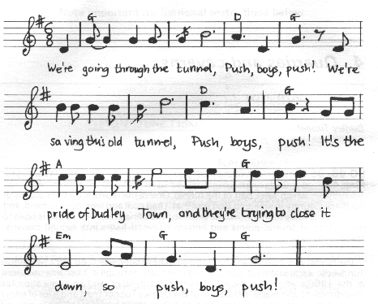

Hard Working Boater

I’m a hard working boater and sharp as a knife
I’ve worked on the Junction for most of me life,
Wi’ a pair of steel boats, seven kids and a wife,
I fancy I’ll carry on boating.

I’ve fought with me windlass and taken some knocks
From the Brummagem wharves to the Weston Point Docks,
And I’ve fought for me turn on the Camden Town Locks
When I’m wanted in Limehouse for loading.

Meself and me missis have nearly been drowned
When working by night on the fifteen mile pound,
Wi’ a big load of spelter for Birmingham bound,
And the weather has been pretty bloody.

I’ve been down to Oxford with a load of D.S.
Fifty-five tons out of Griff Arm, no less,
And I’ve boated to Wellingbro’, two boats abreast,
When the water’s been coming down floody.

You can talk of your rail and your old Highway Code,
But there’s nowt like a pair wi’ a fifty ton load,
When your butty swims well and you get a good road
Right over the Cowroast to Leighton.

So wind up your motor and let your blades churn,
Keep a sharp eye on the oil that you burn,
And feel for the snatch from the butty astern,
And don’t keep the company waiting.
